**Uber Analysis Project Documentation**

**Table of Contents**

* **Introduction  
   1.1 Project Overview  
   1.2 Objectives  
   1.3 Dataset Description**
* **Tools and Technologies**

**2.1 Project Needs**

**2.2 Comprehensive Installation:**

**2.3 Environmental Variables  
2.4 Create Environment**

* **Project Requirements And Libraries**
* **Methodology**

**4.1 Imported Libraries  
 4.2 Data Collection  
 4.3 Data Preprocessing  
 4.4 Exploratory Data Analysis (EDA)**

* **Insights and Findings**
* **Analysis and Results  
   6.1 Key Metrics  
   6.2 Visualizations**
* **Challenges and Solutions**
* **Conclusion and Recommendations**
* **Future Scope**
* **References**

**Introduction**

**1.1 Project Overview**

The **Uber Analysis** project focuses on uncovering valuable insights from Uber trip data through detailed exploration and analysis. Ride-sharing platforms like Uber generate vast amounts of data daily, offering a unique opportunity to analyze user behavior, trip patterns, and operational efficiency. This project leverages a dataset containing critical details, such as trip timings, **pickup and dropoff locations**, trip durations, and distances, to identify trends and patterns. By examining factors like peak hours, high-demand locations, seasonal variations, and user preferences, **the project provides actionable insights that can guide strategic decisions.** The analysis also highlights opportunities for optimizing driver allocation, improving service availability during peak times, and enhancing the overall user experience. Ultimately, this project demonstrates the power of data-driven approaches in shaping the operational strategies of ride-sharing services.

**1.2 Objectives**

The primary objectives of the **Uber Analysis** project are:

1. **Understand Trip Trends and Patterns:**  
   Analyze the data to identify key trends such as peak hours, popular routes, and seasonal variations in ride demand.
2. **Evaluate Operational Efficiency:**  
   Examine trip duration, distance, and distribution of rides across locations to identify areas for potential operational improvements.
3. **Enhance Resource Allocation:**  
   Provide insights to optimize driver allocation during high-demand periods and underutilized times.
4. **Identify Popular Locations:**  
   Determine frequently used pickup and dropoff locations to improve service availability and planning in these areas.
5. **Support Data-Driven Decision Making:**  
   Generate actionable recommendations for Uber's business strategy, including targeted promotions and operational adjustments.
6. **Visualize Key Metrics:**  
   Use data visualization techniques to effectively communicate insights and findings to stakeholders.

**1.3 Dataset Description**

he dataset used in the **Uber Analysis** project provides detailed information about ride requests, enabling the study of ride patterns, driver availability, and service efficiency. The dataset includes the following key columns:

1. **request_id:**  
   A unique identifier for each ride request. This helps in distinguishing individual requests and tracking specific rides.
2. **pickup_point:**  
   Specifies the starting location of the ride, which can be categorized into predefined points such as "City" or "Airport."
3. **driver_id:**  
   The unique identifier for the driver handling the request. If this value is null, it indicates that no driver was assigned to the request.
4. **status:**  
   Represents the outcome of the ride request, which can have values such as:
   * **Completed:** The ride was successfully completed.
   * **Cancelled:** The request was canceled by the user or the driver.
   * **No Cars Available:** Indicates that the request could not be fulfilled due to a lack of available drivers.
5. **request_timestamp:**  
   The exact date and time when the ride request was made. This column is crucial for analyzing demand patterns, peak hours, and time-based trends.
6. **drop_timestamp:**  
   The exact date and time when the ride ended. This is used to calculate trip durations and evaluate ride completion times

**Tools and Technologies**

**2.1 Project Needs**

To achieve optimal performance, this project employs Jupyter interactive environment for exploratory data analysis and visualization, Python as the primary programming language for implementing algorithms and data processing workflows, and Anaconda as an integrated platform for managing packages, dependencies, and virtual environments. These tools work in unison to facilitate seamless data analysis, streamline code execution, and enhance reproducibility. This setup supports efficient handling of large datasets, simplifies dependency management, and provides an organized framework for developing and documenting the analysis process.Notebook as an

**2.2 Comprehensive Installation:**

**1.Downloading and Installing Python**

**Visit the Official Python Website**  
 Go to <https://www.python.org>, the official Python website.

**Navigate to the Downloads Section**  
On the homepage, click on the **Downloads** tab. The website will automatically detect your operating system (Windows, macOS, or Linux) and recommend the most compatible version of Python for your system.

**Select the Appropriate Version**

1. For general purposes, choose the latest stable release (e.g., Python 3.x.x).
2. If you require a specific version for compatibility reasons, scroll down to the list of previous releases and select the version you need.

**Download the Installer**

1. **Windows**: Download the .exe file.
2. **macOS**: Download the .pkg file.
3. **Linux**: Follow your distribution’s specific instructions (e.g., using apt, yum, or dnf for package managers).

**Verify Installation**

1. Open a terminal (Command Prompt, PowerShell, or equivalent).
2. Type one of the following commands, depending on your system like python --version

**2. Downloading and Installing Anaconda**

1. Visit the official Anaconda website: <https://www.anaconda.com>.
2. Navigate to the Download section.
3. Choose the installer for your operating system and download it.
4. Run the downloaded installer file.
5. Open a terminal or command prompt and run the following command to verify the installation of Anaconda: **conda –version**

**Setting Up Jupyter Notebook**

**Step 1: Launch Jupyter Notebook via Anaconda Navigator**

1. Open **Anaconda Navigator**.
2. Locate **Jupyter Notebook** and click **Launch**.
3. The Jupyter interface opens in your default browser.

**Step 2: Launch Jupyter Notebook via Command Line**

1. Open a terminal or command prompt :- jupyter notebook

**Step 3: Test Jupyter Notebook**

1. Create a new notebook by clicking **New** > **Python 3**.

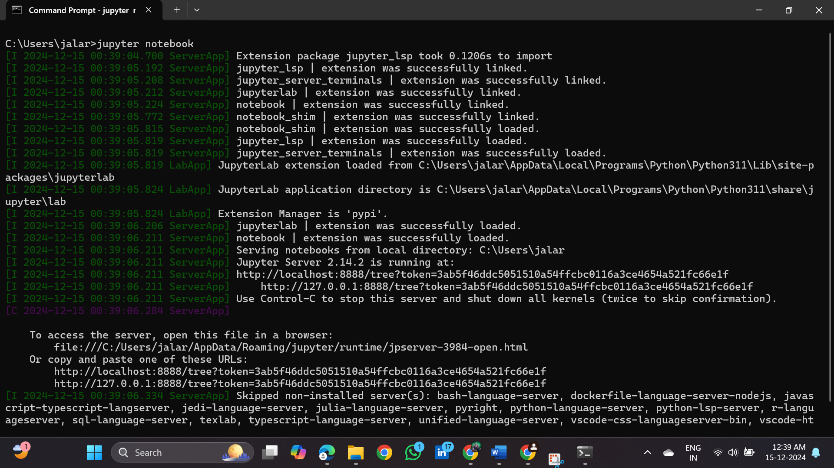

**2.3 Environmental Variables**

Setting up the environment involves several critical steps to ensure the project runs smoothly and efficiently. This process begins with installing all required libraries and dependencies, using tools like Anaconda or pip for package management. Configuring environment variables ensures proper communication between components and supports seamless execution. Additionally, compatibility checks are performed to align the software versions (e.g., Python version and libraries) with project requirements. This meticulous setup guarantees a stable and consistent environment, reducing errors and enhancing the reproducibility of the project workflow.



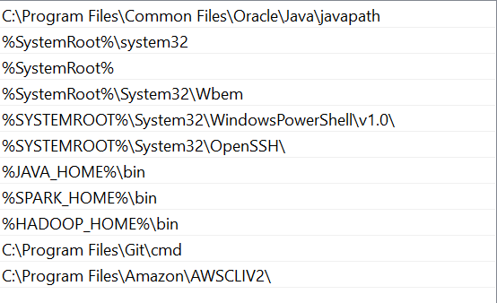

**2.4 Create Environment**

The project environment is configured to store Jupyter Notebook files on the local desktop for convenient access and management. A dedicated directory is created to organize the notebooks systematically, ensuring that all project files are easily accessible and stored in a structured manner, directly on the user's local system.

And I used global Python script (**environment.py**) is created and used to execute the analysis. This file contains all the necessary imports, configurations, and reusable functions for executing Python code.

**C:\myproject\uber_analysis**

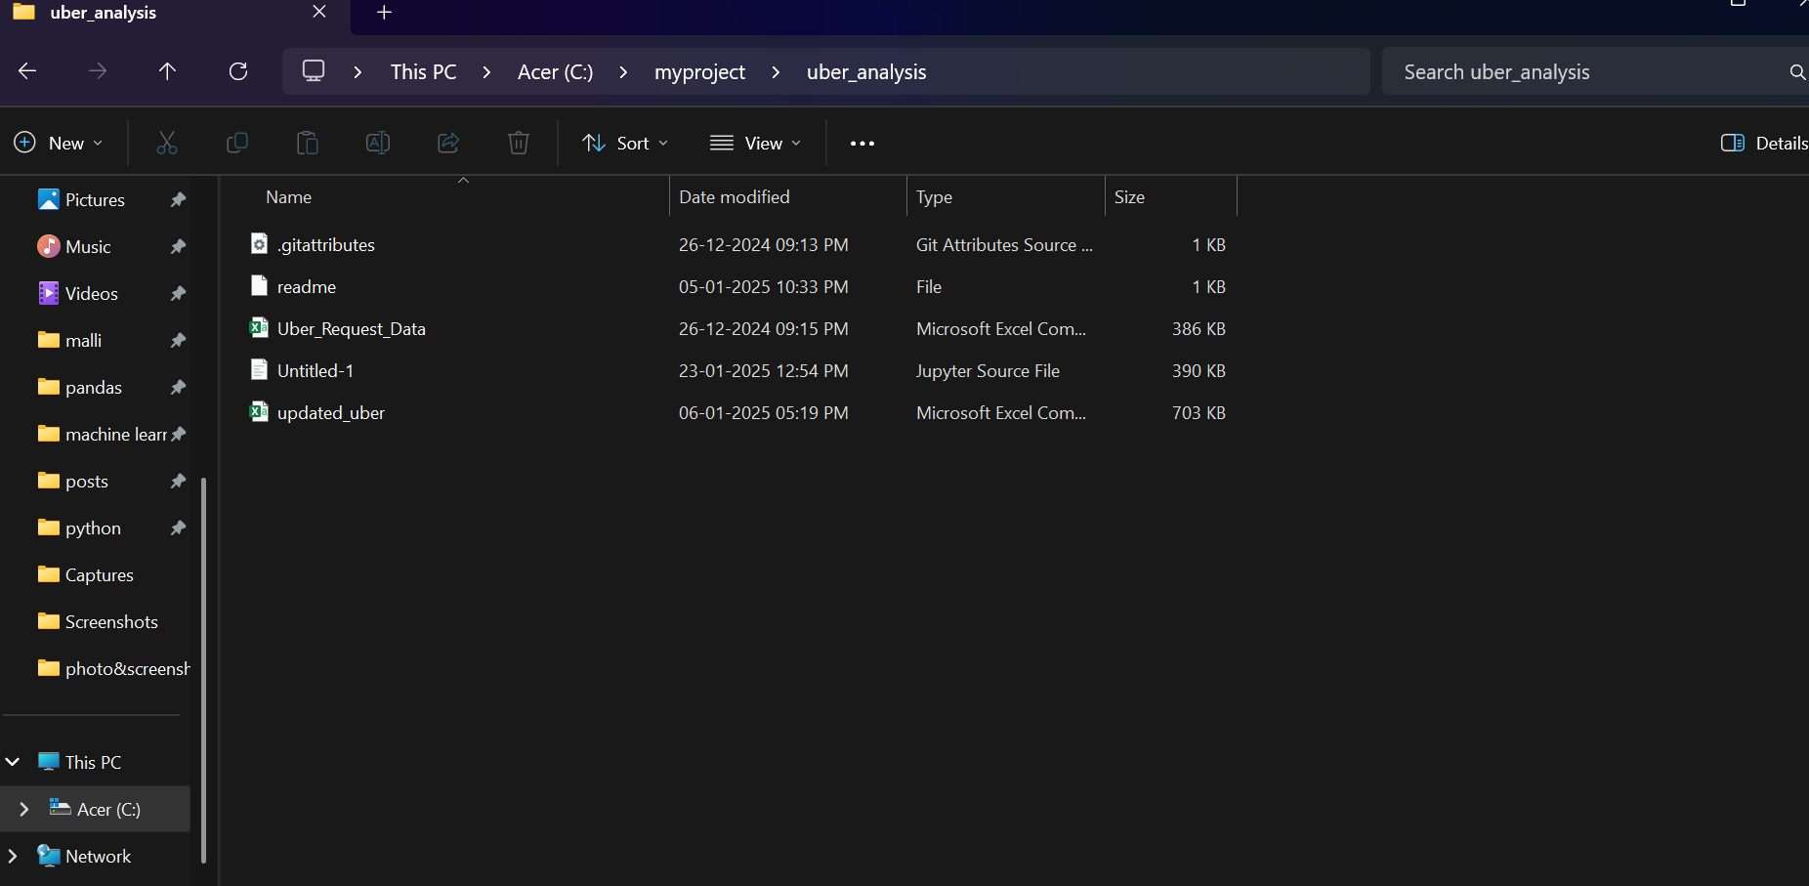

**Project Requirements And Libraries**

The project requires essential libraries and tools to facilitate smooth execution and efficient data analysis. Key requirements include Python as the programming language, Jupyter Notebook for interactive development, and libraries such as Pandas, NumPy, and Matplotlib for data manipulation and visualization. These components ensure seamless integration, robust performance, and scalability to meet the project’s objectives.

**Methodology**

**4.1 Imported Libraries**

To begin the analysis, I imported the necessary libraries into the Jupyter Notebook environment, including Pandas for data manipulation, NumPy for numerical operations, and Matplotlib for data visualization. This allowed me to efficiently work with the dataset, perform data processing, and generate meaningful insights using the powerful features provided by these libraries.

**4.2 Data Collection**

The dataset used in the **Uber Analysis** project was provided by **Instrovate Technologies**. It contains detailed information about Uber ride requests, including attributes like request ID, pickup and dropoff points, driver IDs, status, and timestamps. To load and analyze the data, **Pandas** was used as the primary data manipulation tool.

**4.3 Data Preprocessing**

Data processing in the **Uber Analysis** project focused on cleaning and transforming the dataset to make it suitable for analysis. The following steps were performed:

1. **Data Loading:**
   * The dataset was loaded into a Pandas DataFrame using the pd.read_csv() function, providing an easy way to handle and manipulate the data.
2. **Handling Missing Values:**
   * Any rows with missing values were dropped using dropna() to ensure the integrity of the analysis. This step was crucial as missing data could lead to biased or inaccurate insights.
3. **Datetime Conversion:**
   * The request_timestamp and drop_timestamp columns, which were initially stored as strings, were converted into proper datetime objects using pd.to_datetime(). This allowed for easier manipulation of time-based features (such as extracting hours, days, and months).
4. **Creating New Features:**
   * From the request_timestamp, new features were created:
     + **Hour of the Day:** Extracted from the timestamp to analyze hourly trends.
     + **Day of the Week:** Extracted to examine weekday vs. weekend patterns.
     + **Month:** To observe seasonal variations and trends.
5. **Data Type Conversion:**
   * Some columns were cast to appropriate data types for optimization and to avoid any errors during analysis. For example, columns like request_id and driver_id were converted into string types.

**4.4 Exploratory Data Analysis (EDA)**

The **Exploratory Data Analysis (EDA)** phase helped in gaining insights into the dataset, identifying trends, and detecting potential issues. The following steps were conducted during EDA:

1. **Summary Statistics:**
   * Basic summary statistics (mean, median, mode) were computed to get an overview of the numeric features. This step also helped in identifying any data irregularities such as extreme outliers.
2. **Distribution of Request Status:**
   * The status of each ride request (status column) was analyzed to understand how many requests were completed, canceled, or had no cars available. A bar plot was generated to visualize the distribution.
3. **Request Timing Analysis:**
   * The request_timestamp was used to study the distribution of requests over different times of the day, weekdays, and months. This was visualized with histograms and time-based plots.
4. **Driver Activity Analysis:**
   * The number of requests per driver (driver_id) was analyzed to determine how frequently each driver handled trips. This helped identify if some drivers were handling a disproportionate number of requests.



**Insights and Findings**

1. **Request Status:**

* A large number of requests were completed, but a notable percentage were canceled or marked as "No Cars Available," indicating potential gaps in service during high-demand periods.

2. **Hourly Trends:**

* Ride requests peaked during morning (7 AM - 9 AM) and evening (5 PM - 8 PM) rush hours, with significantly lower demand late at night (12 AM - 5 AM).

3. **Day-wise Analysis:**

* Weekends showed higher ride demand, but **Wednesday** had the highest number of successful (completed) rides, likely due to consistent weekday commuting patterns.

4. **Time vs. Day Analysis:**

* Most rides occurred during the **daytime** (morning and evening hours).
* The **nighttime** (post-midnight) had the lowest number of rides across all days.

5. **Driver Activity:**

* A few drivers handled most requests, highlighting an imbalance in workload distribution.

6. **Geospatial Trends:**

* High-demand locations included city centers and airports, with dense clusters of pickups and drop-offs.

7. **Trip Patterns:**

* Longer distances correlated with longer durations, though some outliers suggested delays due to traffic or other factors

**Analysis and Results**

**6.1 Key Metrics**

1. **Total Ride Requests:**  
   The total number of ride requests made during the analyzed period.
2. **Completed Rides:**  
   The number and percentage of successfully completed rides.
3. **Canceled Rides:**  
   The number and percentage of rides canceled by users or drivers.
4. **No Cars Available:**  
   The number and percentage of requests that could not be fulfilled due to driver unavailability.
5. **Peak Request Hours:**  
   Identifying the hours with the highest and lowest number of ride requests.
6. **Day with Most Completed Rides:**  
   The day of the week with the highest number of successfully completed rides (e.g., Wednesday).
7. **Time of Day Analysis:**  
   Metrics for ride requests during daytime (morning and evening rush hours) vs. nighttime (late-night hours).
8. **Driver Utilization Rate:**  
   The average number of requests handled by each driver, indicating workload distribution.
9. **Geographical Trends:**  
   High-demand pickup and drop-off locations, such as city centers or airports.
10. **Trip Duration and Distance:**
    * Average trip duration.
    * Average trip distance.
    * Analysis of outliers for trips with unusually high durations or distances.
11. **Cancellation Rate:**  
    The proportion of canceled rides compared to the total ride requests.
12. **Driver Availability Rate:**  
    The proportion of rides where drivers were available, providing insight into resource allocation.

**6.2 Visualizations**

The project involves using visualizations such as pie charts, bar charts, and line charts to explore and analyze Uber ride request data. These visual tools help in identifying key patterns, such as the distribution of ride statuses (completed, canceled, and "No Cars Available"), ride request trends by hour, and day-wise performance. The bar charts offer insights into the volume of successful rides on different days, with Wednesday standing out as the day with the most completed rides. Additionally, visualizations like histograms and stacked bar charts help uncover driver workload distribution, geographic demand patterns, and cancellations. The insights derived from these visualizations are crucial for understanding service gaps, demand fluctuations, and operational inefficiencies, thereby guiding data-driven decisions for improving Uber’s service delivery and resource allocation.

For further details, you can refer to the [github_project_link](https://github.com/mallikarjunads/uber_analysis/blob/main/Untitled-1.ipynb).

**Challenges and Solutions**

In this project, several challenges were encountered, such as handling missing data, dealing with duplicates, and ensuring proper data formatting. To address these, the dataset was cleaned by imputing missing values and removing duplicates. Data encoding was also applied to handle categorical variables. Additionally, visualizations helped identify trends and relationships, making it easier to interpret complex data patterns. These solutions helped ensure the data was ready for further analysis and model-building

**Conclusion:**

This project provided valuable insights into Uber's ride request data, identifying key patterns related to ride status, peak demand times, and driver workload. The analysis revealed that the highest number of successful rides occurred on Wednesday, with ride requests peaking during morning and evening rush hours. Additionally, the data indicated that daytime hours experience higher demand than nighttime, while certain drivers were handling a disproportionate number of requests. Geospatial analysis highlighted high-demand areas such as city centers and airports, which are essential for optimizing Uber's operational strategy.

**Recommendations:**

1. **Optimize Driver Allocation:**  
   Uber should ensure that drivers are distributed more evenly across regions to avoid imbalances, particularly in high-demand areas like city centers and airports. Predictive analytics could help forecast demand, enabling better allocation of drivers during peak hours.
2. **Enhance Service Availability During Peak Times:**  
   Uber should focus on improving service availability during peak hours (morning and evening) and explore strategies to reduce the number of "No Cars Available" requests during high-demand periods.
3. **Targeted Promotions:**  
   Offering targeted promotions on weekdays, especially Wednesday, could help increase demand further and improve overall ride completion rates.
4. **Geographic Expansion:**  
   Expanding analysis to include multiple cities or regions could uncover additional trends and help Uber optimize service offerings in different markets.
5. **Invest in Dynamic Pricing:**  
   Implementing dynamic pricing models based on time of day, ride duration, and geographic location could help Uber better manage demand fluctuations and improve profitability.

**Future Scope**

he future scope of this project involves expanding the analysis to enhance Uber's operational efficiency and customer experience. First, incorporating more granular data, such as ride duration, distance, and customer ratings, could provide deeper insights into factors affecting ride completion and user satisfaction. Implementing predictive modeling could help forecast demand during peak hours, allowing Uber to better allocate drivers and reduce the number of "No Cars Available" requests. Integrating real-time data could enable dynamic pricing analysis based on ride demand, geographic location, and time of day. Furthermore, exploring advanced machine learning techniques like clustering could identify underserved areas where Uber could increase driver availability. Lastly, expanding the geographic scope of the analysis to cover multiple cities or countries could offer insights into regional performance variations, helping Uber optimize its global operations.

**References**

For this project, I extensively utilized a variety of resources to ensure a thorough understanding and successful execution. These included Kaggle notebooks, which provided practical examples and community-driven insights; Stack Overflow, where I found solutions to technical challenges and clarifications on implementation details; and my course material, which served as the foundation for key concepts and methodologies. Additionally, I referred to Jason Brownlee's tutorials, which offered in-depth explanations of machine learning techniques, and various YouTube videos that provided visual demonstrations and practical tips. Together, these resources played a pivotal role in guiding me through the project's development and enhancing my knowledge base.

---------------------------------------- Thank you --------------------------------------